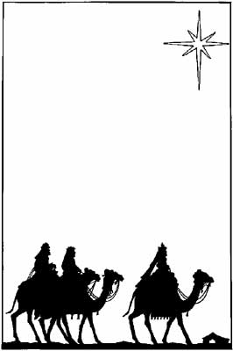
Christmas
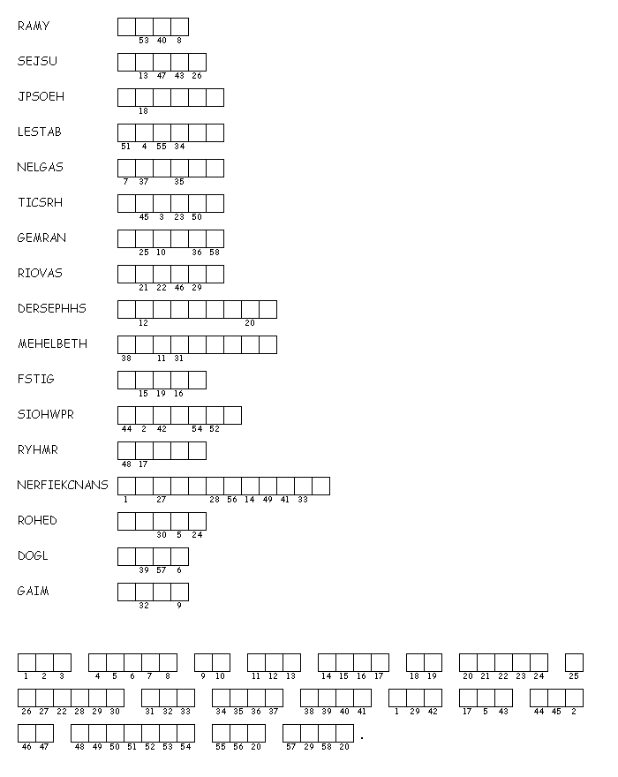 Unscramble each of the clue words.
Copy the letters in the numbered cells to other cells with the same number.

Created by Puzzlemaker at DiscoverySchool.com

Answers: (For younger students you can put a word bank on the board).

Mary
Jesus
Joseph
Stable
Angels
Christ
Manger
Savior
Shepherds
Bethlehem
Gifts
Worship
Myrrh
Frankincense
Herod
Gold
Magi

For today in the city of David a savior has been born for you who is Messiah and Lord.
Luke 2:11 NAB

